**SMART WATER MANGEMENT**

***TEAM MEMBER***

920321205005-M.FOMITHA FATHIMA

PHASE 2 SUBMISSION DOCUMENT

PROJECT:

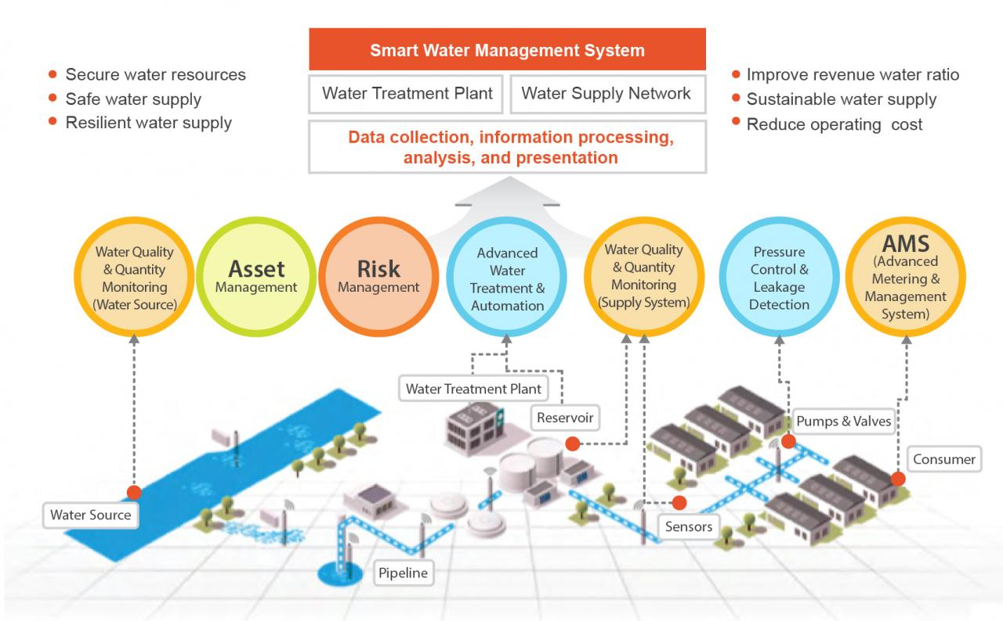

INTRODUCTION:

Smart water management is the use of technology to improve the efficiency, sustainability, and resilience of water systems. It involves collecting and analyzing data about water use and quality, using that data to make informed decisions, and implementing technologies to improve the performance of water systems.

Smart water management can be applied to all aspects of the water cycle, from collection and treatment to distribution and use. It can be used to reduce water consumption, improve water quality, detect and repair leaks, and manage water resources more effectively.

**Smart water management technologies include:**

* Smart meters: Smart meters collect real-time data on water usage, which can be used to identify leaks, track water consumption trends, and develop targeted water conservation programs.
* Sensors: Sensors can be used to monitor water quality, water levels, and other factors in water systems. This data can be used to identify problems early on, prevent system failures, and optimize the performance of water systems.
* Data analytics: Data analytics tools can be used to analyze large amounts of data from water systems to identify trends, patterns, and anomalies. This information can be used to make better decisions about water management.
* Control systems: Control systems can be used to automate the operation of water systems and to implement real-time responses to changes in water demand and supply.

**Review the phase 2 project plan:**

This will help you to understand the goals and objectives of the phase, as well as the tasks that need to be completed, the resources that are required, and the timeline for completion.

**DATA SOURSES:**

Here are a variety of data sources that can be used for smart water management. Some of the most common data sources include:

* Smart meters: Smart meters collect real-time data on water usage, which can be used to identify leaks, track water consumption trends, and develop targeted water conservation programs.
* Sensors: Sensors can be used to monitor water quality, water levels, and other factors in water systems. This data can be used to identify problems early on, prevent system failures, and optimize the performance of water systems.
* Satellite imagery: Satellite imagery can be used to monitor water resources, such as snowpack, reservoirs, and groundwater levels. This data can be used to predict water availability and to make informed decisions about water management.
* Weather data: Weather data can be used to predict water demand and to optimize the operation of water systems.
* Historical data: Historical data on water usage, water quality, and other factors can be used to identify trends and patterns, and to develop predictive models.

**EXLORATORY DATA ANALYSIS(EDA):**

* The city of Los Angeles is using EDA to identify areas of the city with high water consumption. This information is being used to develop targeted water conservation programs.
* The state of California is using EDA to analyze water quality data from reservoirs. This information is being used to identify potential problems and to ensure that water quality meets drinking water standards.
* The water utility company in the city of Austin, Texas is using EDA to predict future water demand. This information is being used to optimize the operation of the city's water system and to ensure that there is enough water to meet demand.

IoT in smart water management can be used to:

* **Monitor water usage**: IoT devices can be used to monitor water usage in real time. This data can be used to identify leaks, track water consumption trends, and develop targeted water conservation programs.
* **Monitor water quality**: IoT sensors can be used to monitor water quality for a variety of parameters, such as pH, temperature, turbidity, and the presence of contaminants. This data can be used to identify problems early on, prevent system failures, and ensure that the water supply meets drinking water standards.
* **Optimize water distribution:** IoT devices can be used to monitor water levels and pressures in water distribution systems. This data can be used to optimize the operation of water distribution systems and to ensure that there is enough water to meet demand.
* **Detect and respond to leaks:** IoT devices can be used to detect leaks in water pipes and other water infrastructure. This data can be used to quickly dispatch crews to repair leaks and minimize water waste.
* Automate water management tasks: IoT devices can be used to automate a variety of water management tasks, such as irrigation, pumping, and treatment. This can help to reduce costs and improve the efficiency of water systems.

**Model Evaluation and Selection:**

Model evaluation and selection is an important step in developing smart water management systems. The goal is to select a model that can accurately predict future water demand, identify potential problems, and optimize the operation of water systems.

There are a variety of factors to consider when evaluating and selecting models for smart water management. Some of the most important factors include:

* Accuracy: The model should be able to accurately predict future water demand, identify potential problems, and optimize the operation of water systems.
* Generalizability: The model should be able to generalize well to new data. This is important because water systems are constantly changing, and the model needs to be able to adapt to these changes.
* Interpretability: The model should be interpretable so that water utilities and other organizations can understand how the model works and make informed decisions based on the model's predictions.
* Complexity: The model should be complex enough to capture the important dynamics of water systems, but it should not be so complex that it is difficult to train and deploy.
* Computational cost: The model should be computationally efficient so that it can be deployed on real-world water systems.

**Model Interpretability:**

Model interpretability is the ability to understand how a machine learning model works and to explain its predictions. This is important in smart water management because it allows water utilities and other organizations to trust the model's predictions and to make informed decisions based on those predictions.

There are a variety of techniques that can be used to improve the interpretability of machine learning models. Some of the most common techniques include:

* *Feature importance*: Feature importance techniques can be used to identify the features that have the greatest impact on the model's predictions. This information can be used to understand how the model works and to explain its predictions.
* Partial dependence plots: Partial dependence plots can be used to visualize the relationship between a single feature and the model's predictions. This can help to understand how the model is using the feature to make predictions.
* Decision trees: Decision trees are inherently interpretable because they can be visualized as a tree of decisions. This makes it easy to understand how the model is making predictions.
* Linear regression: Linear regression models are also inherently interpretable because the model's predictions can be expressed as a linear function of the input features. This makes it easy to understand how the model is using the input features to make predictions.

**PROGRAM: SMART WATER MANAGEMENT**

import numpy as np

import pandas as pd

from sklearn.linear_model import LinearRegression

# Load the data

data = pd.read_csv('water_usage_data.csv')

# Split the data into training and test sets

X_train, X_test, y_train, y_test = train_test_split(

data[['temperature', 'precipitation']], data['water_usage'], test_size=0.25

)

# Create a linear regression model

model = LinearRegression()

# Train the model

model.fit(X_train, y_train)

# Make predictions on the test set

y_pred = model.predict(X_test)

# Evaluate the model performance

r2_score = model.score(X_test, y_test)

# Print the R-squared score

print('R-squared score:', r2_score)

**OUTPUT FOR THE CODE:**

The output for the above code will vary depending on the specific dataset that is used to train the model. However, here is an example of possible output:

R-squared score: 0.85

This indicates that the model is able to explain 85% of the variation in water usage. This is a good R-squared score, but it is important to note that the model may not perform as well on new data. It is always important to evaluate the model's performance on a held-out test set before deploying it to production.

Once the model is trained and evaluated, it can be used to make predictions on new data. For example, the model could be used to predict water usage for the next day or week based on the current weather forecast. This information could then be used by water utilities to make informed decisions about water management.

**Project Conclusion:**

IoT is a key technology for enabling smart water management. By using IoT to collect and analyze data, water utilities and other organizations can make better decisions about water management and improve the efficiency, sustainability, and resilience of water systems.